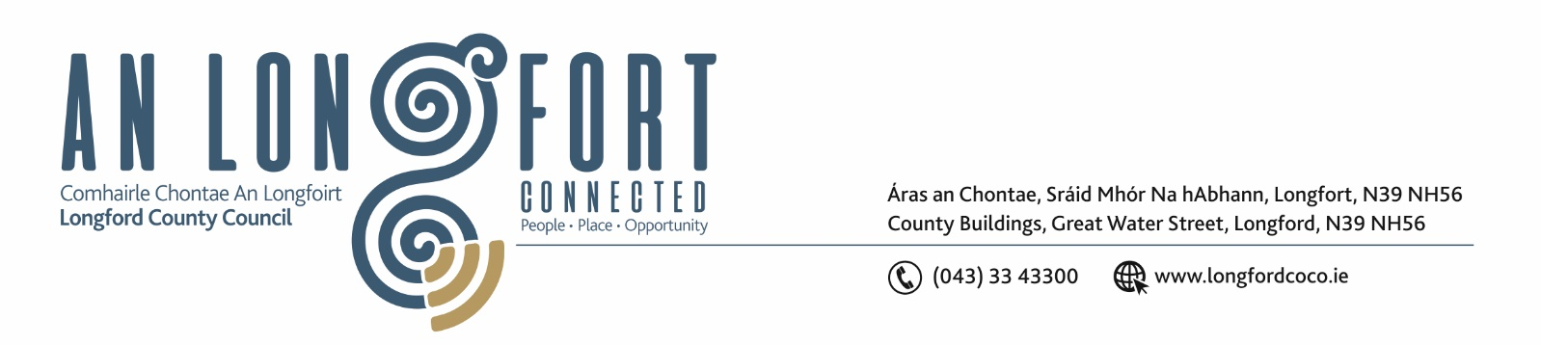

8u Mi na Samhna 2018

Chuig: Gach Ball don Chomhairle.

A Chomhairleoir,

Iarrtar ort bheith i láthair ag Cruinniú Míosuil Chomhairle Chontae Longfoirt a tionólfar i Seomra na Comhairle, Aras an Chontae, Longford ar an Chéadaoin, 14u Mi na Samhna 2018 ag 3.30 p.m chun gnó a dhéanamh d’réir an Chláir thíos.

You are requested to attend the Monthly Meeting of Longford County Council to be held in the Council Chamber, Aras an Chontae, Great Water Street, Longford on Wednesday, 14th November 2018 at
3.30 p.m. to transact business, as set out on the Agenda hereunder.

A presentation will be held at 6.30 p.m. to the Contract Cleaners from St. Christophers Services who provided cleaning services in the offices of Longford County Council over the past number of years.

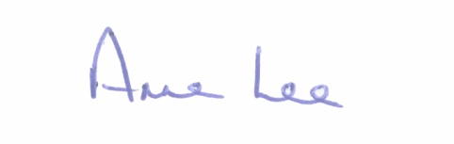
Mise le meas,

__________________
Anne Lee,
Meetings Administrator.

C L A R

3.30 p.m.
- James Cawley, Policy Officer, Independent Living Movement Ireland, will attend the Meeting.

5.30 p.m.
- Representatives from IDA Ireland will attend the Meeting.

- Confirmation of Minutes of Monthly Meeting of Longford County Council held on the
10th October 2018 – copy enclosed.

- Matters arising from Minutes.

- To note Chief Executive Orders - enclosed.

4. To note Monthly Management Report - to follow.

5. To note adopted Minutes of Corporate Policy Group Meeting held on
18th September 2018 - (copy enclosed).

6. Housing, Infrastructure, Environment & Emergency Services.

- Appointment of one member to Infrastructure & Environment Strategic Policy Committee.

7. Economic and Community Development, Planning, Human Resources & Corporate Services, Cultural & Recreational Services.

- To note Planning Applications received since October meeting of the Council.

- Regional Spatial and Economic Strategy Update

- Notices of Motions submitted by Councillors, as listed hereunder –

Councillor Joe Flaherty.
“That Longford County Council re-activates the cross agency group formed in the wake of the Cameron closure and allow it to evolve as a high level transition forum that will focus on future plans for Bord na Mona facilities and assets in the region.
It is vital that Co Longford now positions itself to ensure that the county and more importantly, the 195 Bord na Mona workers based here, are positioned to benefit from the next phase. Similar moves are afoot in other counties and I am proposing that transitional forums for counties Longford, Offaly, Westmeath, Kildare and Roscommon would then come together and leverage the best possible supports for the affected workers.”
Councillor P.J. Reilly.
“That Longford County Council consider how it might support communities in their application for LEADER funding.”

8. Finance & Information Systems.
(a) To note Public Liability Claims received during October 2018.

- Local Authority Elected Members Role & Remuneration Review - Correspondence from Department of Housing, Planning and Local Government enclosed.

9. General

(i) Notices of Motions, submitted by Councillors, as listed hereunder –

Councillor John Browne.

“I call on Longford County Council to write to the HSE and Mr. Simon Harris, T.D., Minister for Health, stating that there is a serious need to scrap the current system being used to process Medical Card Applications and issue Cards, as it is completely antiquated and not fit for purpose.”

Councillor Paul Ross.

“That this Council seeks the immediate replacement by the HSE of the 2 child psychologist posts which are currently vacant in the Longford/Westmeath area.”

10. Votes of sympathy.

11. Training -
Consideration of Report from Corporate Policy Group.



